Chief Patron
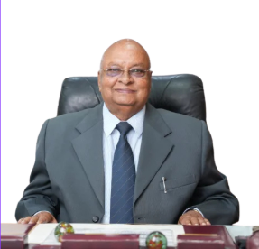
Shri R.C. Mittal, Chancellor
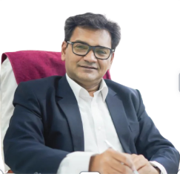
Shri Gopal Agrawal, Pro Chancellor
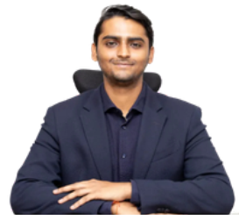
Shri Palash Garg, OSD to Chancellor

Ms. Saloni Garg, Director Promotion & Branding

Patron
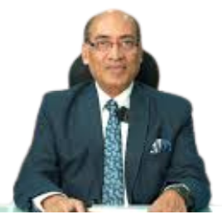
Prof. D.K. Patnaik, Vice Chancellor
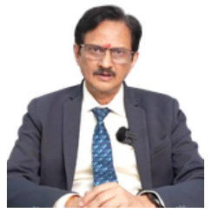
Prof. Birajashis Pattnaik, Pro Vice Chancellor
General Chair
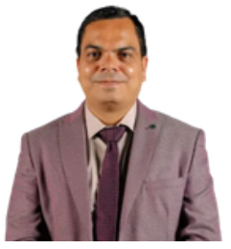
Dr. Ratnesh Litoriya, Dean of Engineering (Computing)
General Co-Chairs
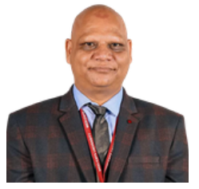
Dr. Kailash Chandra Bandhu, Head of Department CSE
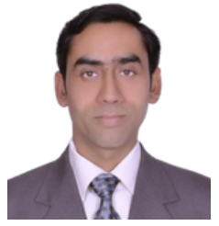
Dr. Prashant Panse, Associate Dean Digitalization
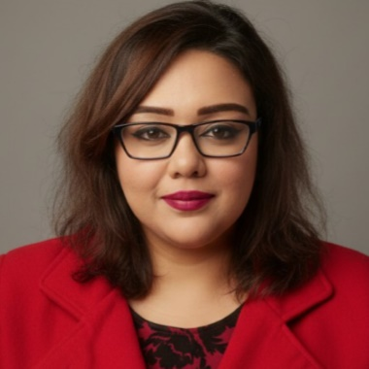
Dr. Anuradha Kar, Associate Professor Aivancity

Publication Chair
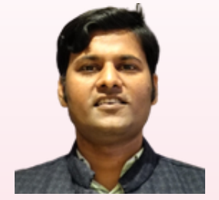
Dr. Sonu Kumar
Finance Chair
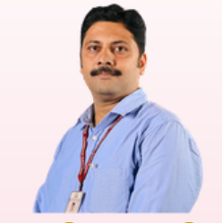
Prof. Rudresh Shah
Publicity Chair
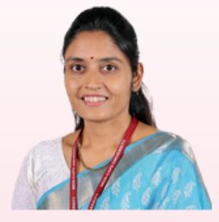
Dr. Latika Jindal
Technical Program Committee Chair
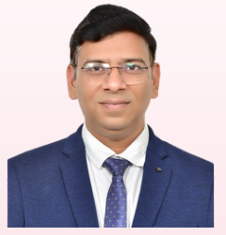
Prof. Sanket Gupta

IEEE Madhya Pradesh Section
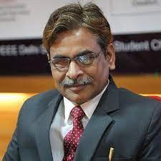
Prof. G S Tomar, Chairperson, IEEE MP Section
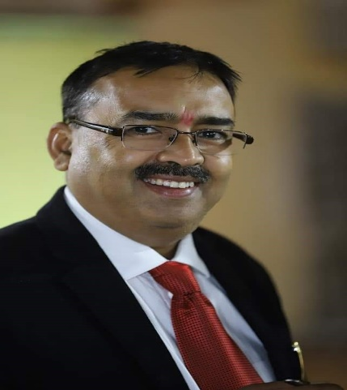
Prof. Manish Dixit, Chair-Elect
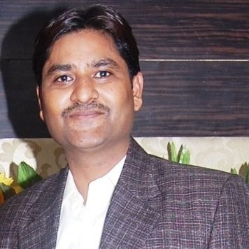
Prof. Jinendra Agrawal, Vice Chairperson
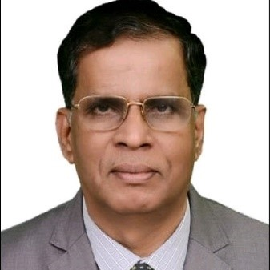
Prof. Manmath Badapanda, Vice Chairperson
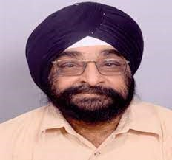
Prof. M P S Chawla, Secretary
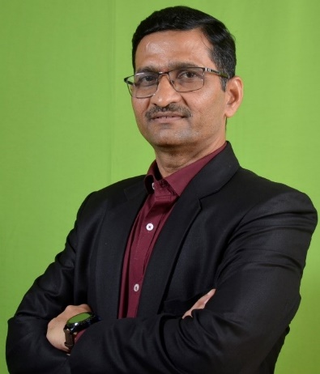
Prof. Durgesh Kumar Mishra, Chair CSE

IEEE France Section
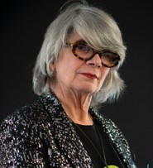
Dr. Florence Sedes, President, IEEE France Section
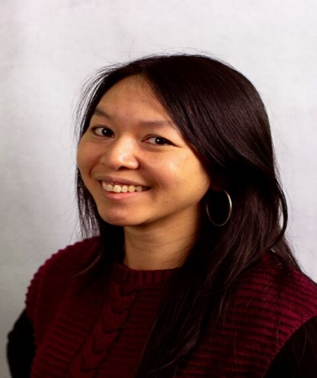
Dr. Marina Deng, Vice President Conferences

Gérard-André Capolino, President, Power Electronics

Roua Touihri, President Computer

Pascal Lorenz, President, Communications

